**Title:** The Efficacy of Different Global Responses to the COVID-19 Pandemic

**Authors:** Alan Luo, Dave Lu, Kefan Cao, Aruneshwar Venkat

**Abstract**

The ongoing COVID-19 pandemic has proven to be one of the deadliest in recorded human history, and as such, has revealed numerous insights for how best to counter disease pandemics. In our project, we use an SEIR model to model the efficacy of different kinds of approaches to combating COVID-19, and to see how stochasticity affects the progression of COVID-19 in this model. The strategies we consider are masking and lockdown, and we distinguish these approaches based on a choice of a model parametre value (the beta1 value). Our results reveal masking to be the superior approach, and stochasticity to cause more deaths in the population. These findings suggest that both masking and lockdowns should continue to be used as mitigation strategies. In addition, we share other areas worthy of more exploration, such as the effects of other kinds of preventative measures and the influence of stochasticity on these kinds of models. If these areas can be better understood, then the world would be better equipped to fight against future disease outbreaks, possibly more deadly than COVID-19.

**Introduction**

The ongoing COVID-19 pandemic has proven to be one of the deadliest in recorded human history [9], claiming over 6.5 million lives around the world and infecting nearly 650 million globally [10]. The ongoing COVID-19 pandemic has also proven influential in helping to develop more effective medical treatments, especially with regards to mitigating infectious diseases. Specifically, the pandemic has revealed the varying degree to which certain preventative measures, such as masking, physical distancing, and vaccination, combat the spread of diseases like COVID-19.

However, despite these differing effects, there have not been many studies on these differences. Furthermore, of the studies that do explore these differences, most use deterministic algorithms rather than stochastic ones. This is an issue because stochasticity may be a more accurate representation of how a disease actually progresses in a population since it accommodates randomness [11]. The reason why is that any virus, not just the SARS-CoV-2 virus, is not particularly selective with what host cell the virus invades. The virus is concerned simply with whether that cell is healthy or not. As such, there is unpredictability in how a virus spreads. Since there is unpredictability, there is also randomness in how a disease progresses.

Therefore, there are two goals to our project. The first one is to find out how certain mitigation strategies compare to each other in terms of effectiveness. The second one is to see how an epidemiological model that simulates COVID-19 progression performs in stochastic conditions. In our project, this epidemiological model is an SEIR model pulled from a model that was shared in lecture. We model each mitigation strategy as a unique set of model parameters. Given the dynamic nature of the (still-ongoing) pandemic, these parameters are best seen as approximations of the true effect of these different approaches. The approaches considered here are the degree to which masking was enforced, and the degree to which lockdown was enforced.

In the rest of this paper, we first provide more details about our model and how we implement this model to get our results. We then present graphs showing different simulations of our model, each one testing a different set of model parameters to represent each of the different mitigation strategies. We conclude by reporting the challenges faced in performing this study, and discussing what our results mean for what kinds of mitigation strategies may work best for countering pandemics.

**Methodology**

We designed our SEIR model based upon a model shown to us in lecture [4]. This model is the below set of differential equations (Fig. 1). Figure 2 is a visualization of our model. The difference is that we make the parameters random so that we work with a stochastic, rather than a deterministic, model. We do this by using a stochastic term, dW (a random variable with a standard Normal distribution), for each of the different products involving a unique rate. Then, we multiply each stochastic term by a constant called k to signify how much we want that term to contribute to the overall stochasticity. This utilized the Euler-Maruyama method taught in lecture. The Euler-Maruyama iterators for the rate of change are presented below.



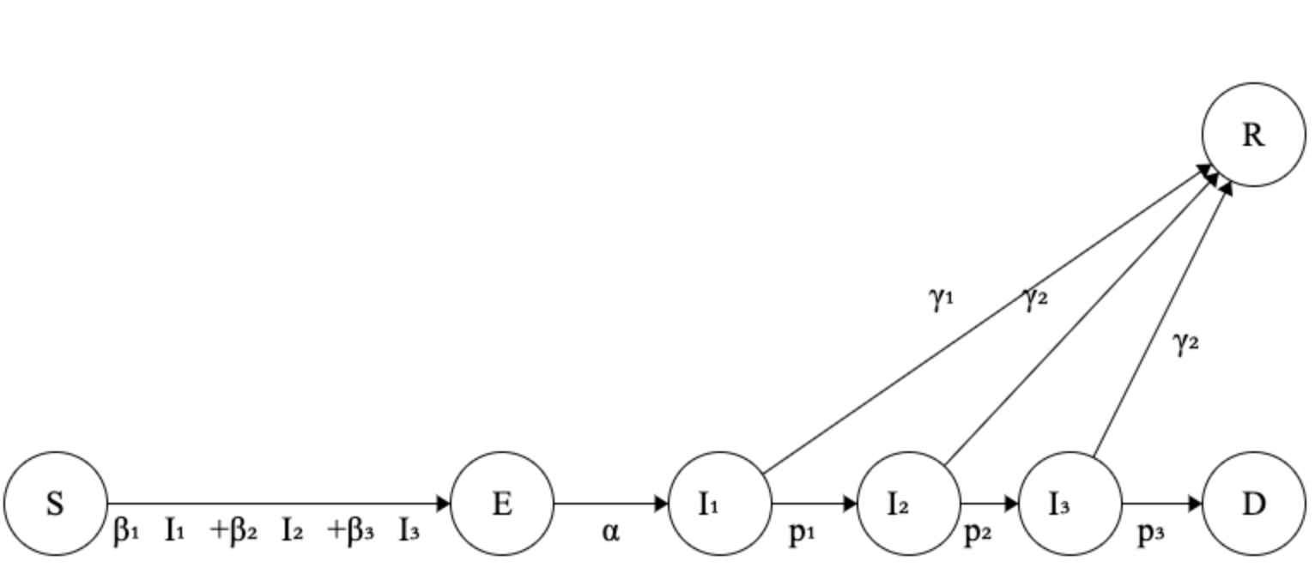

Fig. 2. Visualization of our SEIR model.

For our parameters, we adjust them based upon the mitigation strategy. These strategies are whether masking is enforced, and whether lockdown is enforced. To distinguish each strategy, we change the beta1 parameter. This parameter is 0.25 for masking, and 0.375 for lockdowns [12]. We then run this model for a fixed number of days (generally 250 or 500 days), and then look at the ratio of the number dead to the total population. This ratio is our measure of efficacy. The lower this is, the better the preventative measure likely was. We do not consider space for our model, due to the abnormally high amount of data that this would require (e.g. building a model on the state or city-level for each country). Finally, the data we use is purely simulated data pulled from the model shown in lecture, pulled from the values given on the left-hand side of the webpage underneath the “Set clinical parameters…” and “Set transmission rates…” headings [4]. For example, our three gamma parameters, each one representing the rate of infection for mild, severe, and critical levels, were 0.5, 0.1, and 0.1, respectively.

Our code implementation is linked here: <https://github.com/daveylu/02512-Project>

**Results**

We performed nine simulations, each one testing different sets of conditions.

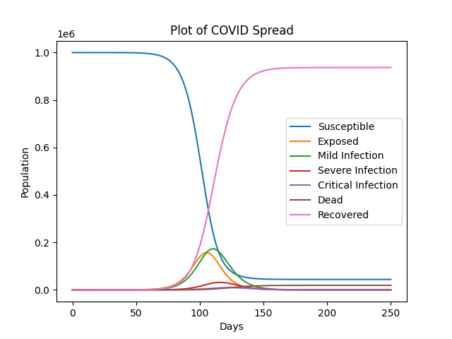

Fig.3 No preventative measures, no stochasticity (k=0)

About 2% of the population died.

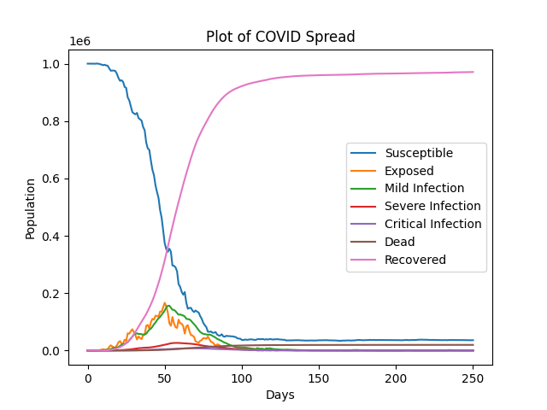

Fig.4 No preventative measures, stochasticity enabled (k=0.1)

About 2% of the population died.

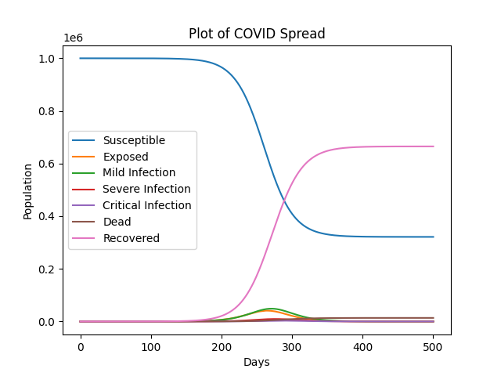

Fig.5 Masking begins at the start of simulation, no stochasticity (k=0)

About 1.36% of the population died.

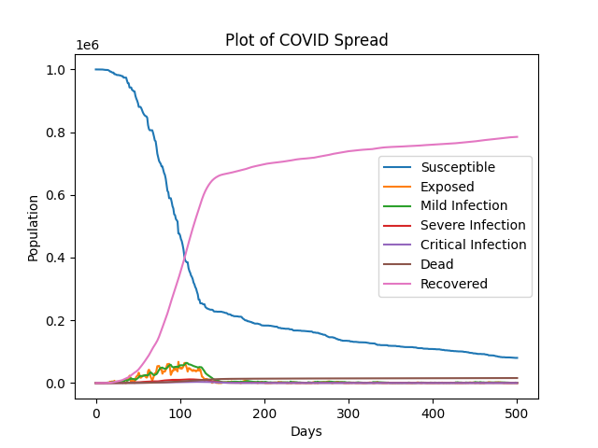

Fig.6 Masking begins at the start of simulation, stochasticity enabled (k=0.1)

About 1.59% of the population died.

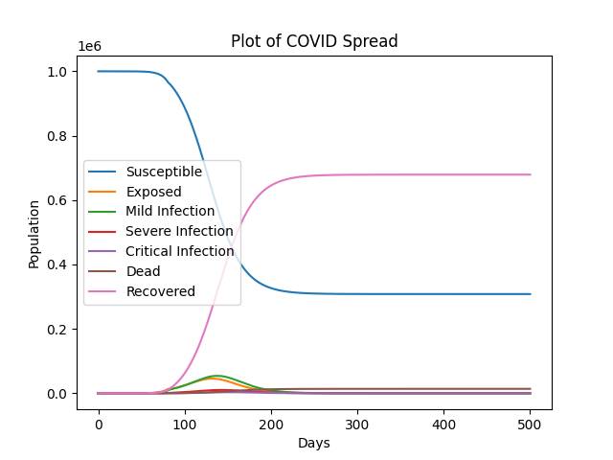

Fig.7 Masking begins when 1% of the population are infected, no other measures, no stochasticity. About 1.39% of the population died.

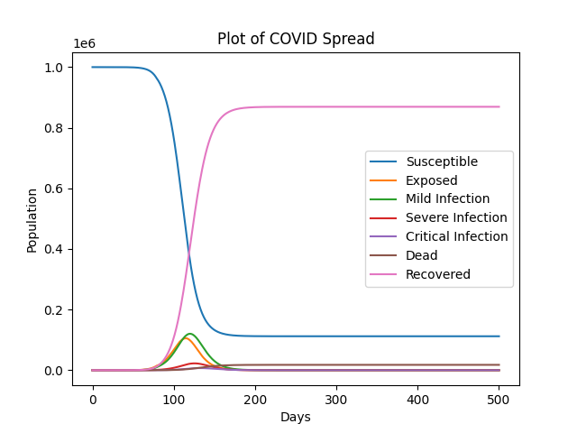

Fig.8 Lockdown begins when 1% of the population are infected, lockdown ends after 60 days, no other measures, no stochasticity (k=0). About 1.77% of the population died.

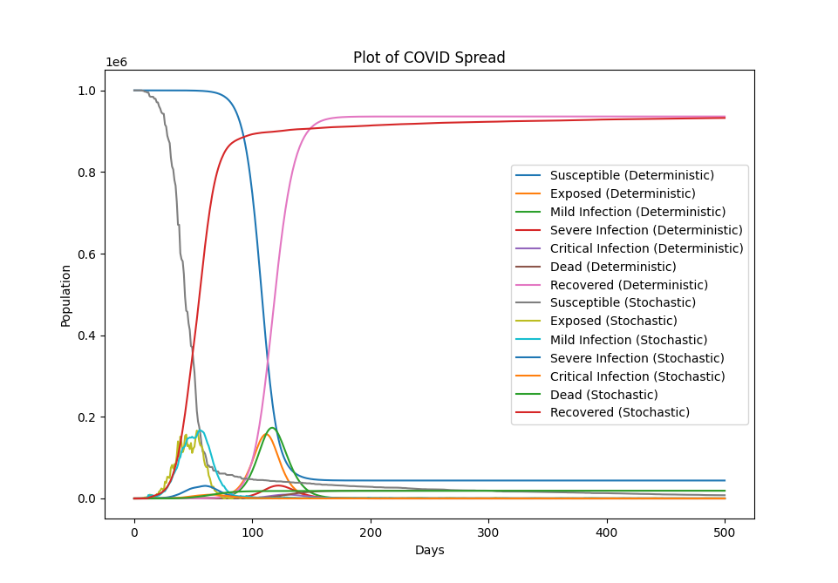

Figure 9. Plot of both the deterministic and stochastic simulations with no preventative measures.

In the deterministic simulation: about 2% of the population died.

In the stochastic simulation: about 2% of the population died.

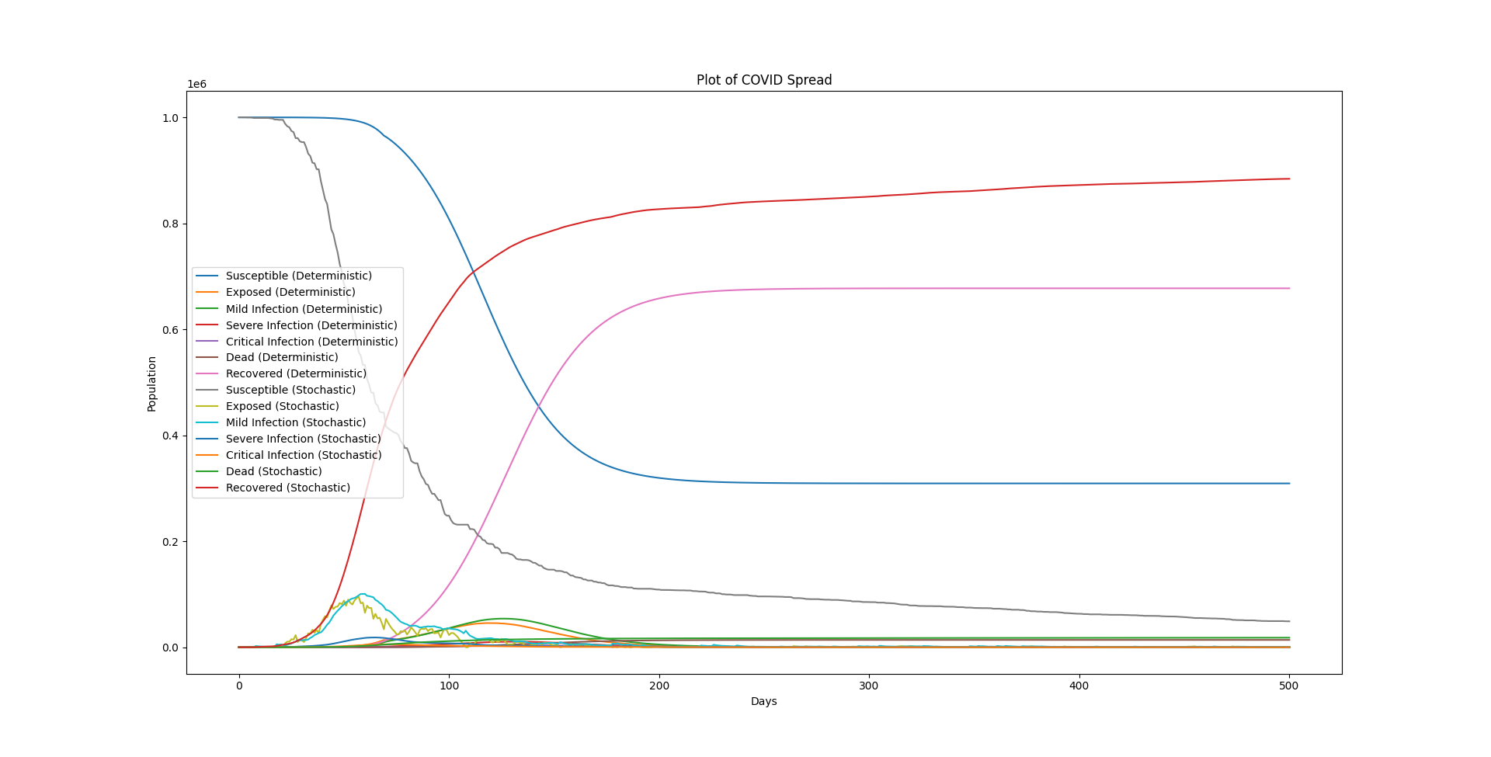

Figure 10. Plot of both the deterministic and stochastic simulations where masking begins when 1% of the population are infected, no other measures.

In the deterministic simulation: about 1.39% of the population died.

In the stochastic simulation: about 1.80% of the population died.

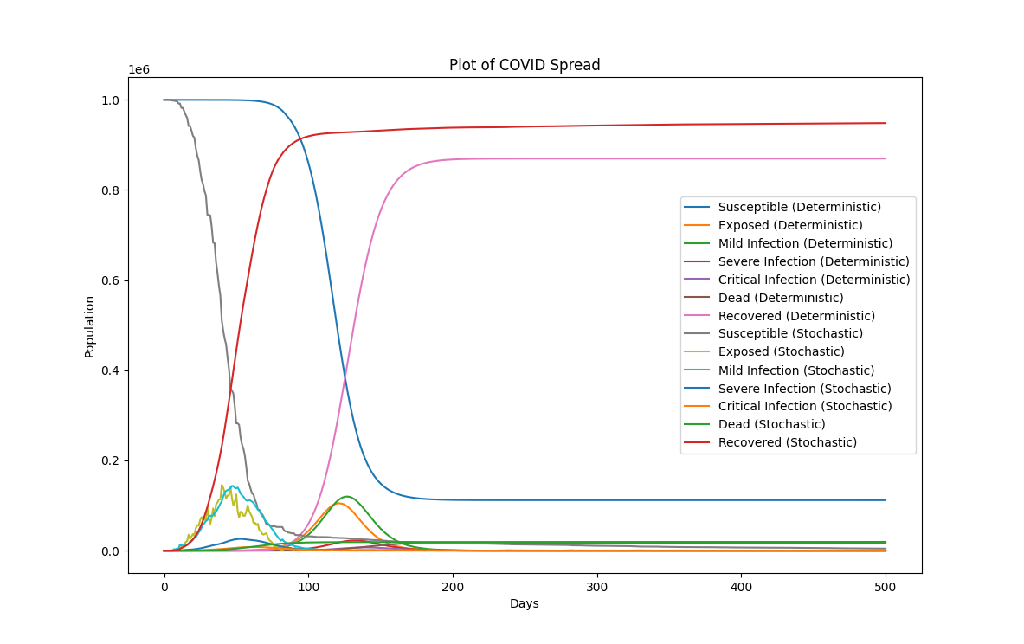

Figure 11. Plot of both the deterministic and stochastic simulations where lockdown begins when 1% of the population are infected, lockdown ends after 60 days, no other measures.

In the deterministic simulation: about 1.77% of the population died.

In the stochastic simulation: about 1.93% of the population died.

**Discussion**

Here, we present an SEIR model to simulate the progression of COVID-19 amongst any given population. We do this by creating a modified version of an existing SEIR model introduced to us in class, using a different choice for each of our beta parameters to represent each of our tested mitigation strategies. In our study, these strategies are masking and population lockdown. We then incorporate stochasticity in our model via the use of differential terms for each of our model rates, scaling the effect of each of these terms (and, in turn, the level of stochasticity) via a “k” value.

The results reveal that masking is a better approach than lockdown. This is evidenced by Figure 7 versus 8, as masking (Figure 7) produces a lower death total than lockdown (Figure 8) does. Lockdown also had a more severe spike in infections, compared to masking. This is not to say, however, that lockdown proved ineffective, as the death rate was still lower for lockdown compared to zero preventative measures (Figures 3 and 4).

Another finding is that stochasticity had the effect of increasing the number of deaths in most simulations, compared to their deterministic counterparts. This is most obviously seen in Figures 11 and 12. A possible explanation for this is that the stochasticity would essentially increase the rate of infection. Because infection rates cannot be negative, we essentially cut out part of the standard Normal distribution that will allow for the negative rates, as that part of the distribution results in a physically impossible value. Our random variable is no longer a standard bell curve, but instead has part of the negative section removed, and redistributed among the rest of the bell curve. This, in essence, shifts the distribution of the random variable to become more positive on average, which in turn increases the rate of infection. This increased rate of infection results in the increased deaths.

There are challenges faced in this project that are worth mentioning here, as they can be useful for future extensions of our study. The first was boundary conditions. An early version of our model had difficulty in dealing with boundary conditions, specifically when any of our model variables threatened to fall below zero. This could happen if, for instance, the population I1 has 4000 people, though the equations say to remove 4500 from I1. This cannot happen, as doing so would lead to a negative I1 population. To solve this problem, we distribute these 4000 people into the next variables in our model. One drawback of this approach is that balancing our differential equations is now harder, since more rearranging is needed to ensure we do not lose any people in our population, nor do we “resurrect” any people, wherein we introduce new people into the living population from the “D” population. Hence, a further investigation should find an alternative to this approach that makes this balancing much simpler.

Another challenge faced was incorporating stochasticity. Our initial attempt at stochasticity resurrected individuals, for instance by transitioning 50 individuals from the death population (“D”) into the critically infected (“I3”) population. We fixed this by restricting the results of certain equations in our model. In the given example, when our dD equation, which governs the change in our death population, tells us to move people from dead to critically infected, we catch that and set the change to zero in both the dD equation as well as the dI3 equation (with respect to movement between D and I3). This prevents the creation of people that did not exist before. If we did not adjust both the dD and dI3 equations, in the given example, I3 would in essence gain 50 people out of nowhere.

Another challenge faced was finding real-world values for our model parameters. The problem here was that we had difficulty finding specific numbers to assign to our beta parameters, as the existing literature on COVID-19 epidemiological models lacked such values. Instead, the researchers in these studies tended to view infection as simply one level, rather than splitting it into three as we did here (mild, severe, critical). As such, a future study should determine these numerical values. Even approximations would prove useful, as these can be fine-tuned through parameter-fitting schemes. Another future study could look at the values for other kinds of mitigation strategies, such as vaccinations, or lower degrees of physical distancing since lockdowns are the most extreme form of physical distancing. In addition, future studies should explore how the progression differs amongst each country, by perhaps comparing U.S., China, and the European Union. The supplementary material includes other possible future studies.

Overall, our work supports the continued uses of both masking and lockdown as mitigation strategies to disease pandemics. Our work also emphasizes the need for further exploration of related areas to this field, including the effects of stochasticity and other kinds of mitigation strategies. If these areas can be better understood, then the world would be better equipped to fight against future disease outbreaks, possibly more deadly than COVID-19.

**Sources**

[1] (U.S. COVID-19 data) <https://covid.cdc.gov/covid-data-tracker/#datatracker-home>

[2] (China COVID-19 data): <https://coronavirus.jhu.edu/region/china>

[3] (India COVID-19 model) <https://www.sciencedirect.com/science/article/pii/S0960077920304756>

[4] (An existing model of COVID-19 spread) <https://alhill.shinyapps.io/COVID19seir>

[5] (ILP for inferring disease complexes) <https://doi.org/10.1093/bioinformatics/btw263>

[6] (the potential of chaos) <https://doi.org/10.48550/arXiv.2110.05266>

[7] (chaos theory and COVID-19) <https://doi.org/10.1017%2FS0950268820000990>

[8] (some of the existing literature on COVID-19 epidemiological models) <https://www.ncbi.nlm.nih.gov/pmc/articles/PMC8642156/>

<https://www.sciencedirect.com/science/article/pii/S0960077920304690>

<https://www.ncbi.nlm.nih.gov/pmc/articles/PMC7270399/>

<https://www.ncbi.nlm.nih.gov/pmc/articles/PMC8113007/>

<https://www.ncbi.nlm.nih.gov/pmc/articles/PMC8571985/>

[9] (COVID-19 statistics) <https://www.gavi.org/vaccineswork/historys-seven-deadliest-plagues>

[10] (COVID-19 statistics) <https://covid19.who.int/>

[11] (evidence on randomness) Witbooi PJ, Muller GE, Van Schalkwyk GJ. Vaccination Control in a Stochastic SVIR Epidemic Model. Comput Math Methods Med. 2015;2015:271654. doi: 10.1155/2015/271654. Epub 2015 May 24. PMID: 26089961; PMCID: PMC4458364.

[12] (beta1 parameter values) Talic S, Shah S, Wild H, Gasevic D, Maharaj A, Ademi Z et al. Effectiveness of public health measures in reducing the incidence of covid-19, SARS-CoV-2 transmission, and covid-19 mortality: systematic review and meta-analysis *BMJ* 2021; 375 :e068302 doi:10.1136/bmj-2021-068302

[13] (European Union COVID-19 data) <https://www.ecdc.europa.eu/en/covid-19/data>

**Supplementary Material**

Below are some other possible ideas considered for this project, which may be explored in the future.

* Model how multiple populations/countries interact with each other with respect to COVID-19.
* Infer disease complexes from existing protein-disease data. (like in [5])
* Use chaos theory to help model the trajectory of any pandemic ([6] and [7] may be useful here)

Below are COVID-19 data pulled from the CDC and other government-affiliated databases. These data document epidemiological aspects of the pandemic, including case counts and death counts. We were unable to find a way to incorporate these data into our project due primarily to a lack of the needed granularity in how severe the infection was for each individual (i.e. mild versus severe versus critical).

* US [1]: <https://covid.cdc.gov/covid-data-tracker/#datatracker-home>
* China [2]: <https://coronavirus.jhu.edu/region/china>
* European Union [13]: <https://www.ecdc.europa.eu/en/covid-19/data>
* India [4]: <https://www.sciencedirect.com/science/article/pii/S0960077920304756>